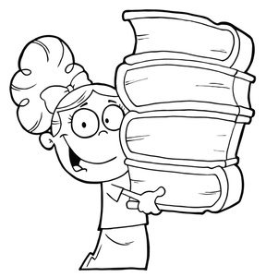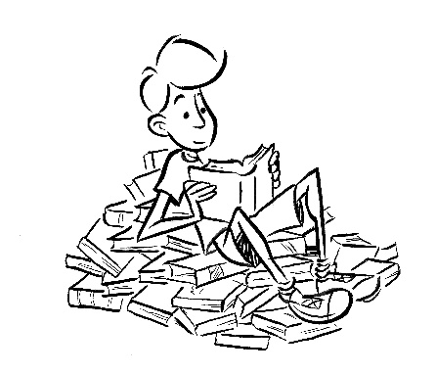

**Bataille des livres - Notre classement**

|  |  |  |  |  |  |  |  |  |  |  |  |  |  |  |  |  |  |  |  |
| --- | --- | --- | --- | --- | --- | --- | --- | --- | --- | --- | --- | --- | --- | --- | --- | --- | --- | --- | --- |
|  | noms des eleves |  |  |  |  |  |  |  |  |  |  |  |  |  |  |  |  |  |  |
| ***titres des livres*** |  |  |  |  |  |  |  |  |  |  |  |  |  |  |  |  |  |  |  |
|  |  |  |  |  |  |  |  |  |  |  |  |  |  |  |  |  |  |  |  |
|  |  |  |  |  |  |  |  |  |  |  |  |  |  |  |  |  |  |  |  |
|  |  |  |  |  |  |  |  |  |  |  |  |  |  |  |  |  |  |  |  |
|  |  |  |  |  |  |  |  |  |  |  |  |  |  |  |  |  |  |  |  |
|  |  |  |  |  |  |  |  |  |  |  |  |  |  |  |  |  |  |  |  |
|  |  |  |  |  |  |  |  |  |  |  |  |  |  |  |  |  |  |  |  |
|  |  |  |  |  |  |  |  |  |  |  |  |  |  |  |  |  |  |  |  |
|  |  |  |  |  |  |  |  |  |  |  |  |  |  |  |  |  |  |  |  |
|  |  |  |  |  |  |  |  |  |  |  |  |  |  |  |  |  |  |  |  |
|  |  |  |  |  |  |  |  |  |  |  |  |  |  |  |  |  |  |  |  |
|  |  |  |  |  |  |  |  |  |  |  |  |  |  |  |  |  |  |  |  |
|  |  |  |  |  |  |  |  |  |  |  |  |  |  |  |  |  |  |  |  |
|  |  |  |  |  |  |  |  |  |  |  |  |  |  |  |  |  |  |  |  |
|  |  |  |  |  |  |  |  |  |  |  |  |  |  |  |  |  |  |  |  |
|  |  |  |  |  |  |  |  |  |  |  |  |  |  |  |  |  |  |  |  |
|  |  |  |  |  |  |  |  |  |  |  |  |  |  |  |  |  |  |  |  |
|  |  |  |  |  |  |  |  |  |  |  |  |  |  |  |  |  |  |  |  |
|  |  |  |  |  |  |  |  |  |  |  |  |  |  |  |  |  |  |  |  |
|  |  |  |  |  |  |  |  |  |  |  |  |  |  |  |  |  |  |  |  |
|  |  |  |  |  |  |  |  |  |  |  |  |  |  |  |  |  |  |  |  |
|  |  |  |  |  |  |  |  |  |  |  |  |  |  |  |  |  |  |  |  |
|  |  |  |  |  |  |  |  |  |  |  |  |  |  |  |  |  |  |  |  |
|  |  |  |  |  |  |  |  |  |  |  |  |  |  |  |  |  |  |  |  |
|  |  |  |  |  |  |  |  |  |  |  |  |  |  |  |  |  |  |  |  |
|  |  |  |  |  |  |  |  |  |  |  |  |  |  |  |  |  |  |  |  |
|  |  |  |  |  |  |  |  |  |  |  |  |  |  |  |  |  |  |  |  |
|  |  |  |  |  |  |  |  |  |  |  |  |  |  |  |  |  |  |  |  |
|  |  |  |  |  |  |  |  |  |  |  |  |  |  |  |  |  |  |  |  |
|  |  |  |  |  |  |  |  |  |  |  |  |  |  |  |  |  |  |  |  |
|  |  |  |  |  |  |  |  |  |  |  |  |  |  |  |  |  |  |  |  |
|  |  |  |  |  |  |  |  |  |  |  |  |  |  |  |  |  |  |  |  |
|  |  |  |  |  |  |  |  |  |  |  |  |  |  |  |  |  |  |  |  |
|  |  |  |  |  |  |  |  |  |  |  |  |  |  |  |  |  |  |  |  |
|  |  |  |  |  |  |  |  |  |  |  |  |  |  |  |  |  |  |  |  |
|  |  |  |  |  |  |  |  |  |  |  |  |  |  |  |  |  |  |  |  |
|  |  |  |  |  |  |  |  |  |  |  |  |  |  |  |  |  |  |  |  |