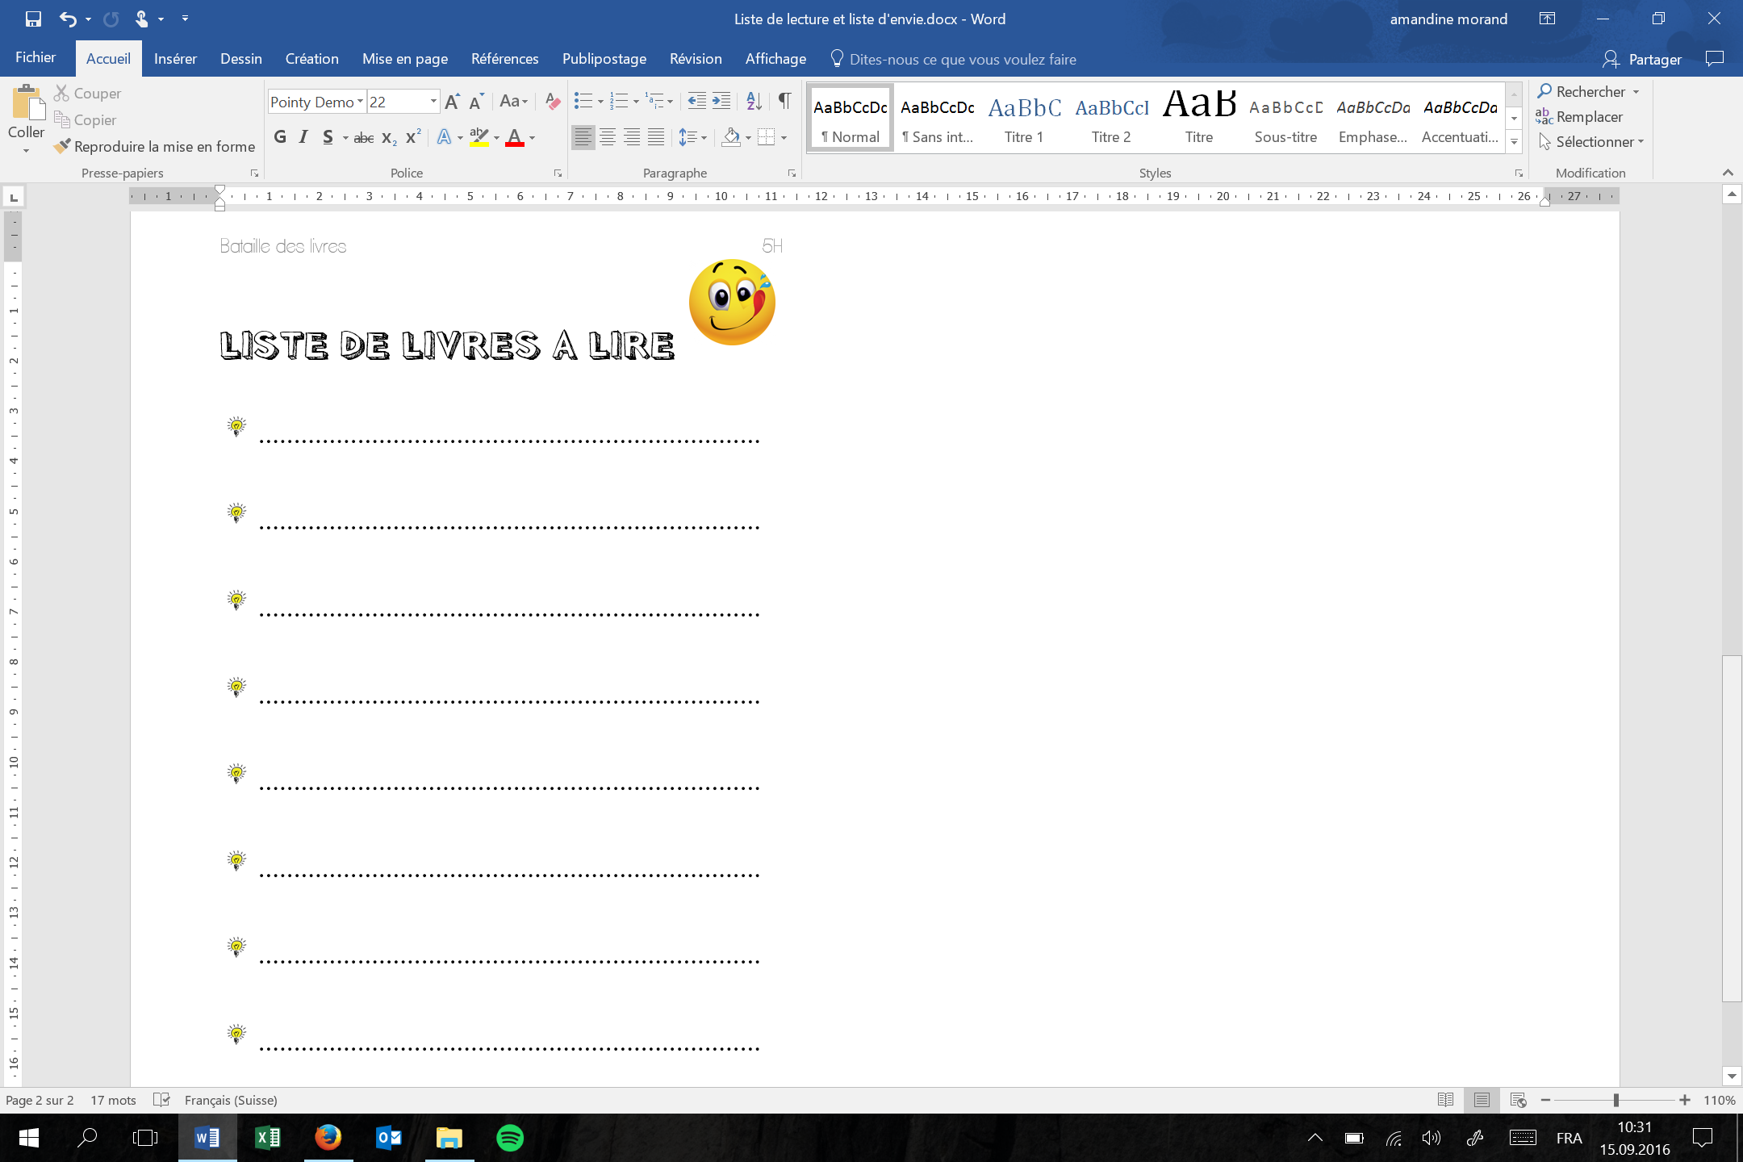

LISTE DE LECTURE

laclassedamy.ch

|  |  |  |  |  |  |  |
| --- | --- | --- | --- | --- | --- | --- |
| http://images.clipartpanda.com/dick-clipart-book01_rgb2.jpg | http://images.all-free-download.com/images/graphiclarge/stop_sign_clip_art_16252.jpg | Titre | http://tulipemedia.com/wp-content/uploads/2012/02/smiley-sceptique-150x150.jpg | http://www.smile-day.net/wp-content/uploads/2012/02/Smiley-Cartoon-Face.jpg | http://delphine-desmarets.com/wp-content/uploads/2010/11/Fotolia_smiley2.jpg | http://www.femoticons.net/images/posts/adore_emoticon_love.png |
|  |  |  |  |  |  |  |
|  |  |  |  |  |  |  |
|  |  |  |  |  |  |  |
|  |  |  |  |  |  |  |
|  |  |  |  |  |  |  |
|  |  |  |  |  |  |  |
|  |  |  |  |  |  |  |
|  |  |  |  |  |  |  |
|  |  |  |  |  |  |  |
|  |  |  |  |  |  |  |
|  |  |  |  |  |  |  |
|  |  |  |  |  |  |  |
|  |  |  |  |  |  |  |